19.54: a)
- b)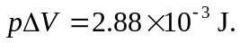
c) 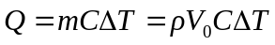
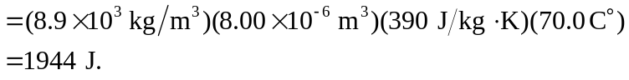
- To three figures, 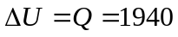 J. e) Under these conditions, the difference is not substantial.

